**How to assign a specific lesson to a student**

If the lessons on iReady are too difficult, you can assign the student a specific lesson for their needs.

1. Once you are logged in to your iReady dashboard select *Assess and Teach* from the top navigation.
2. Press *Instruction* on the side and then select the subject you would like to assign the lesson in.(reading or math)

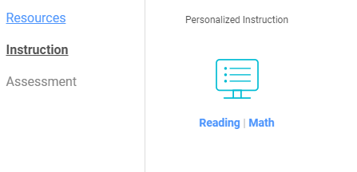

1. When you scroll down you will see create assignment. Select which lesson you would like to assign to the child. You can search by domain or grade by clicking in the boxes going across.

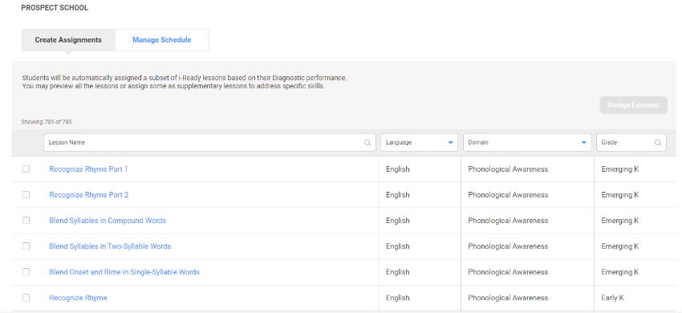

1. Once you have selected the lesson there should be a check next to the lesson (s). Then you will press the green button *Assign lessons.*

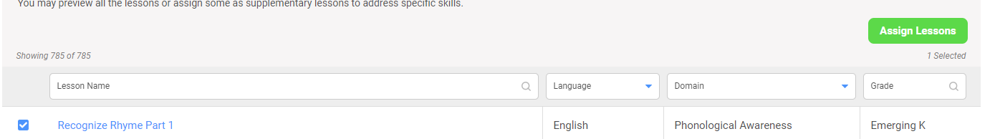

1. Click on students and then press the green arrow on the bottom.
2. 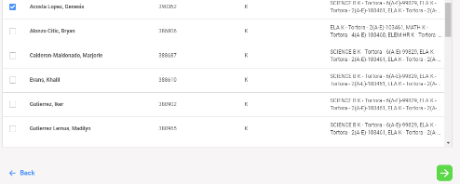Check off the student(s) you would like to assign the lesson to, and then press the green arrow on the bottom.

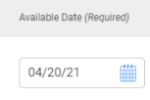

1. 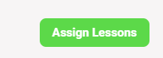Select the date you would like it assigned.
2. Press assign lesson. Refresh the page.

The lesson has now been assigned to the student(s).